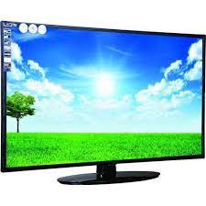

LCD Monitor

* Power Source Electric
* Screen Size 32inches
* 1366 X 768 Pixels
* Brightness 200 Nits
* **29,500**